OasisLMS Stylesheet Settings
Majority of the time, selecting one of the themes will provide a reasonable styling for your instance of OasisLMS (Dashboard Stylesheet Setting).
You can make additional customization by following this guide.
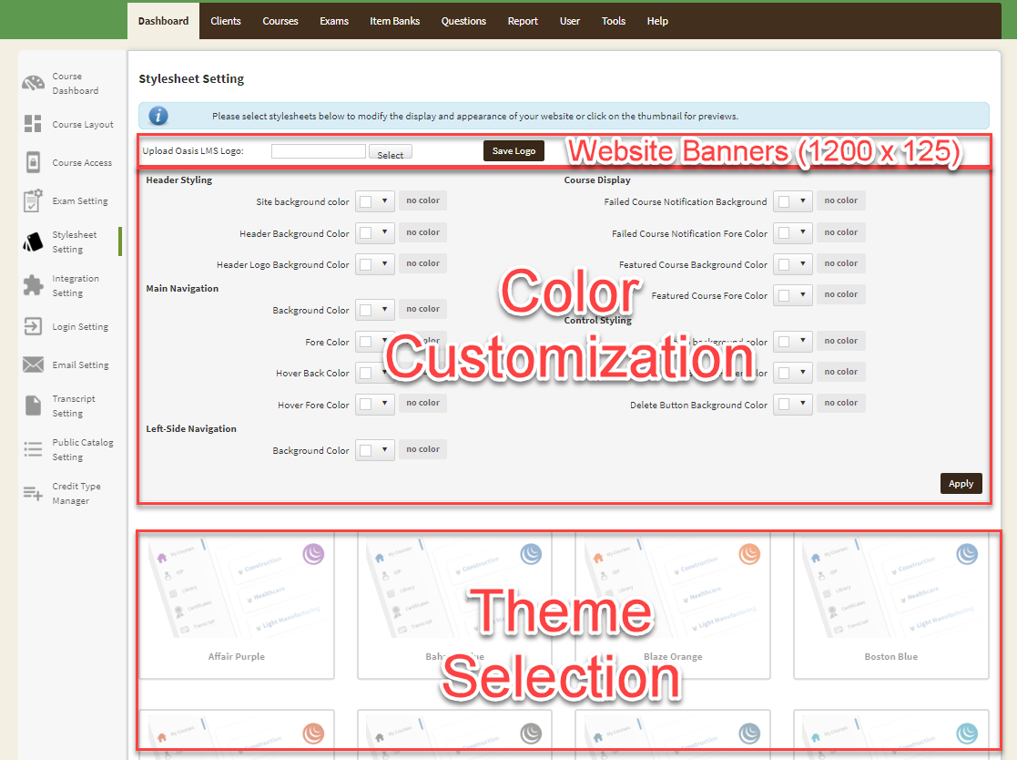
Main Site Styling
The website’s primary styling is controlled by Header Styling, and augmented by Left-side Navigation.
Header Styling
The overall website background color is controlled by the three color-pickers within the “Header Styling” section:
- Header Logo Background Color This is the background of website’s top section
It only applies the area where website banner doesn’t cover
It is recommended to match this color with the color of the website banner
You can upload a transparent logo, and have a solid color that shows through

- Header Background color This is the section right below the banner section, right above the main content area
This section has the user’s name
Don’t use a color that makes user’s name hard to read

- Site background color This is for website’s main background
Note that the middle of the website (content area) will always have white background
It is ok to have white background for this color, matching the white background of the content area
Left-side Navigation
- Background color Background color for user’s navigation section is controlled here.

Use the reference below to match which color-picker is responsible for which “web part”
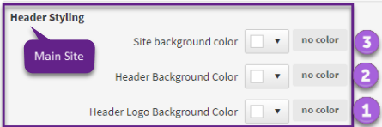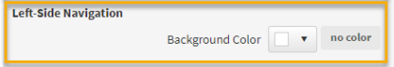
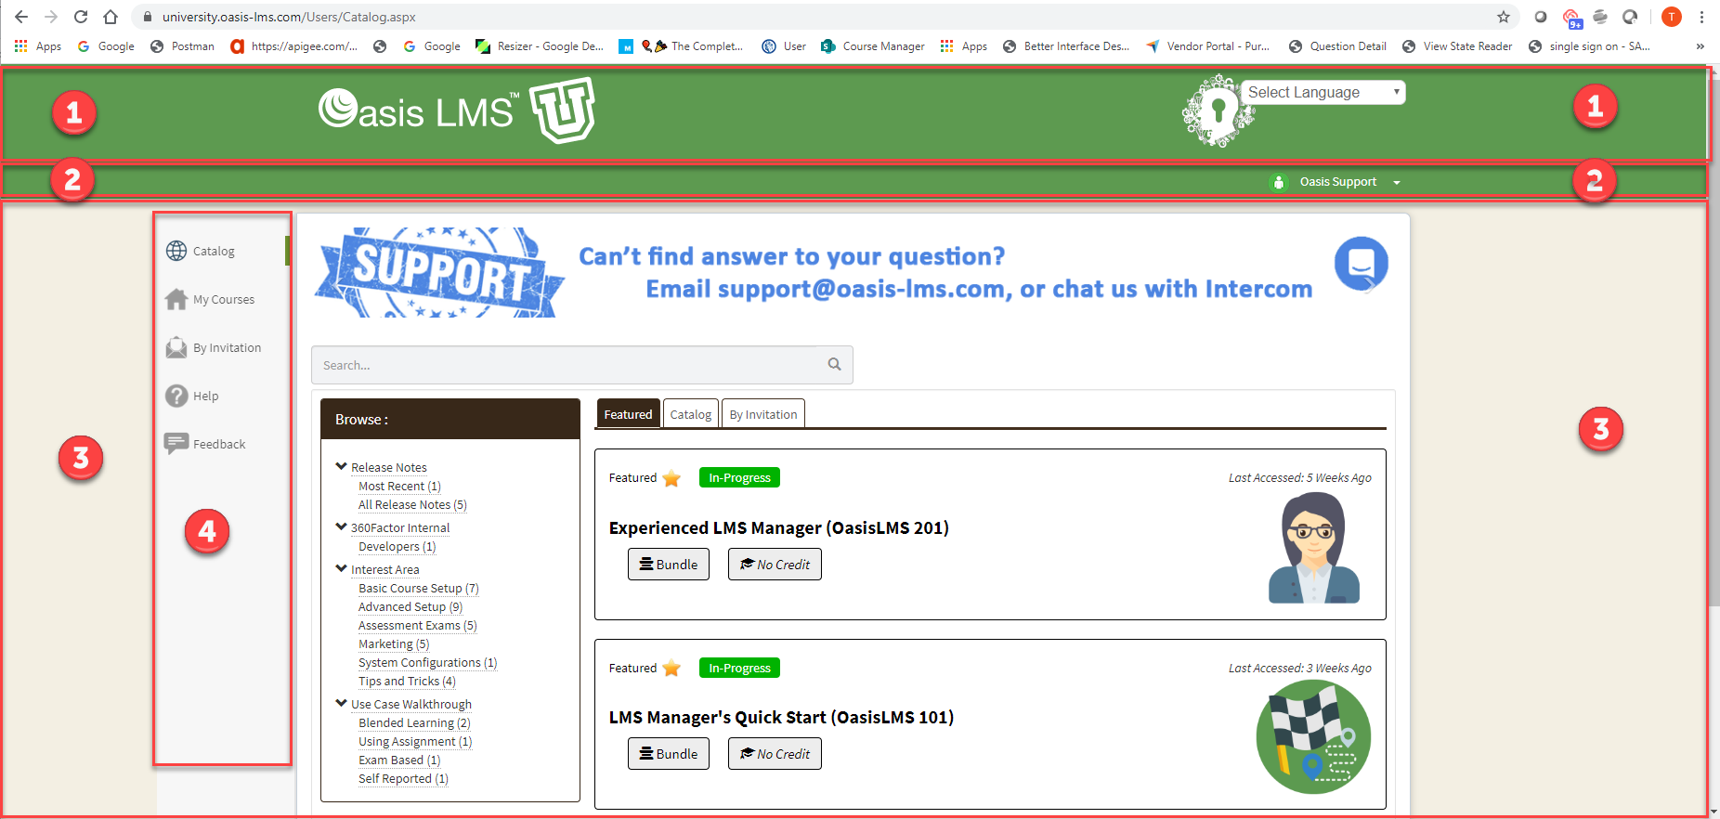

Special User Notification Background Styling
OasisLMS has a few sections that has special meanings, and allows each client to deviate from the default color for these sections. 360Factor is constantly adding additional sections whose styling can be overwritten. Currently, only Failed Course Notification and Feature Course can be managed within Course Display.
Use the reference below to match which color-picker is responsible for which “section”:
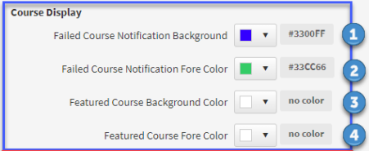
Course Display – Failed Course Notification
If you want a slightly different color for the “Failed Course Notification”, you can use the setting below:
- Failed Course Notification Background This is the background color of the panel
- Failed Course Notification Fore Color This is the font color for the text in the panel
Note that, the actual message displayed for the “Failed Course Notification” is controlled by the administrator setting up the course, if it needs to deviate from the default message.
The screenshot below shows where the panel is, but with the default styling.
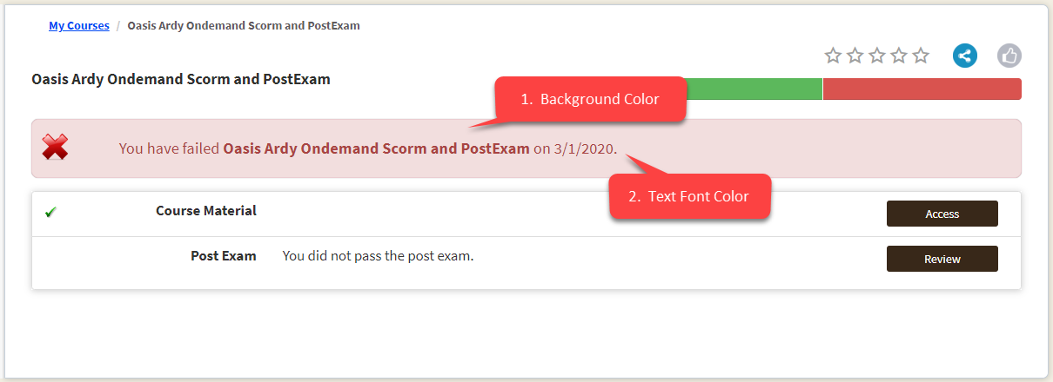
Course Display – Featured Course
By default, the “Feature Course” panel has black background with white text over it. If you want a slightly different color for the “Featured Course” panel, which is only displayed on the catalog, you can use the setting below:
- Featured Course Background Color This is the background color of the feature course panel
- Featured Course Fore Color This is the font color for the text in the feature course panel
It is recommended that a darker for color is selected, if a lighter background color is selected, to allow contrast..
The screenshot below shows where the panel is, but with the default styling.

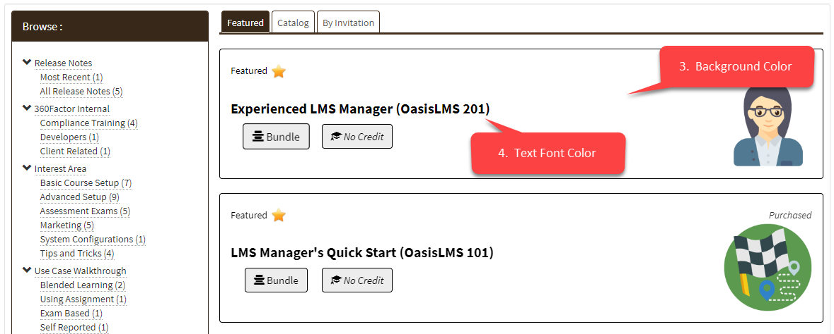

Button Styling
The website’s buttons only have 2 colors (normal + hover), with one additional color that is used for buttons that will perform a “destructive” action. These colors are managed within Button Styles.
Button Styles
The color of the buttons can be controlled by the three color-pickers within “Control Styling” section:
- Button background color This is the button color by default
- Button Hover Color This is the button color when user mouse over the button
- Delete Button Background Color This is if a button is destructive, such as a delete action
This allows a differentiation of colors on two buttons that are next to each other
By default, it is “red”
Use the reference below to match which color-picker is responsible for which “web part”
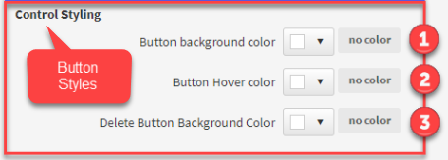

Menu Button Styling
OasisLMS has a horizontal row of buttons for administration menu, and has an option to enable a set of navigation menu for learners as well (turned off by default). The buttons on this navigation button can deviate from the default styling, by selecting the color-picker inside Main Navigation.
Main Navigation
The color of the buttons can be controlled by the three color-pickers within “Control Styling” section:
